PLOTTING - BASICS

You do not need much programming. Little prerequisites will work for you.

There are two steps to follow.

1. [How to write a mathematical equation in MATLAB?](https://dipslab.com/mathematical-functions-expressions-matlab-explain-examples/)
2. How to plot a graph using MATLAB Plotting function?

Table of Contents

* [Important Functions to Plot MATLAB Graph](https://dipslab.com/plot-matlab-graph/#Important_Functions_to_Plot_MATLAB_Graph)
  + [1. How to add a title to the MATLAB graph?](https://dipslab.com/plot-matlab-graph/#1_How_to_add_a_title_to_the_MATLAB_graph)
  + [2. How to add label text to the MATLAB graph axis?](https://dipslab.com/plot-matlab-graph/#2_How_to_add_label_text_to_the_MATLAB_graph_axis)
  + [3. How to add a grid to the MATLAB graph?](https://dipslab.com/plot-matlab-graph/#3_How_to_add_a_grid_to_the_MATLAB_graph)
* [Example of Plotting MATLAB Graphs](https://dipslab.com/plot-matlab-graph/#Example_of_Plotting_MATLAB_Graphs)
  + [Problem 1: How to plot the MATLAB graph for the given equation in MATLAB?](https://dipslab.com/plot-matlab-graph/#Problem_1_How_to_plot_the_MATLAB_graph_for_the_given_equation_in_MATLAB)
  + [Problem 2: How to plot a Sin Function in MATLAB?](https://dipslab.com/plot-matlab-graph/#Problem_2_How_to_plot_a_Sin_Function_in_MATLAB)
  + [Problem 3: How to plot the Exponential Function in MATLAB?](https://dipslab.com/plot-matlab-graph/#Problem_3_How_to_plot_the_Exponential_Function_in_MATLAB)
  + [Problem 4: How to plot the Trigonometric Function in MATLAB?](https://dipslab.com/plot-matlab-graph/#Problem_4_How_to_plot_the_Trigonometric_Function_in_MATLAB)

**Important Functions to Plot MATLAB Graph**

**Study of MATLAB plotting:**

For two-dimensional graph plotting, you require two vectors called ‘x’ and ‘y’.

The simple way, you can draw the plot or graph in MATLAB by using code.

When you write the program on the MATLAB editor or command window, you need to follow the three steps for the graph.

* Firstly, define the value of ‘x’ or other variables range of the value by using the linespace or colon.
* Put the given equation by using the mathematical function of MATLAB. In standard form, y= f(x).
* Use the ‘plot’ function as plot(x,y).

To make the graphs look better visually and to make it easily understandable, consider adding three most important notions in your any graph.

* Title to your graph so that the user can easily identify the importance of the graph.
* Label for ‘x’ and ‘y’ axes to identify the values on the axes.
* Adding a grid can help the user to compare various values are a different point on the graph.

Always follow the first two notions. The third notion is optional though.

To do this, MATLAB has three different functions.

**1. How to add a title to the MATLAB graph?**

Title function is used for writing the title or name of the equation on the plot.

title('.......... ')

**2. How to add label text to the MATLAB graph axis?**

Label functions ‘xlabel’ and ‘ylabel’ are used to add the label text for x-axis and y-axis, respectively.

xlabel('x')

ylabel('y')

**3. How to add a grid to the MATLAB graph?**

In the MATLAB programming, we can plot the graph without the grid or with the grid.

By default, the grid will not be shown on the graph. You have to add it explicitly.

When you want to draw the graph with the grid in MATLAB, you can use the ‘grid’ function.

grid on

With the help of these rules and functions, I am solving the different mathematical equation (problems) in MATLAB.

**Example of Plotting MATLAB Graphs**

Now let’s take different examples to plot MATLAB graphs based on various mathematical functions.

**Problem 1: How to plot the MATLAB graph for the given equation in MATLAB?**

y=(xˆ2+12x+24)

for the value of x between 0 to 12.

**Solution:**

In the given equation, the range of the ‘x’ is 0 to 12. And there will be ‘y’ value corresponding to each x value in that range.

x=(0:1:12) or x =(0,1,12)

and

y=(x^2+4*x+16)

**MATLAB code for the given mathematical function:**

Here is a simple code in MATLAB, to draw the graph for the given equation.

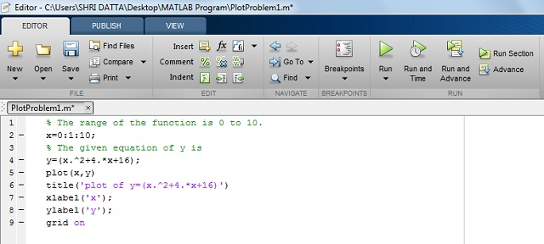

**Output in MATLAB:**

When you run the program, you will get a MATLAB graph along with the grid display.

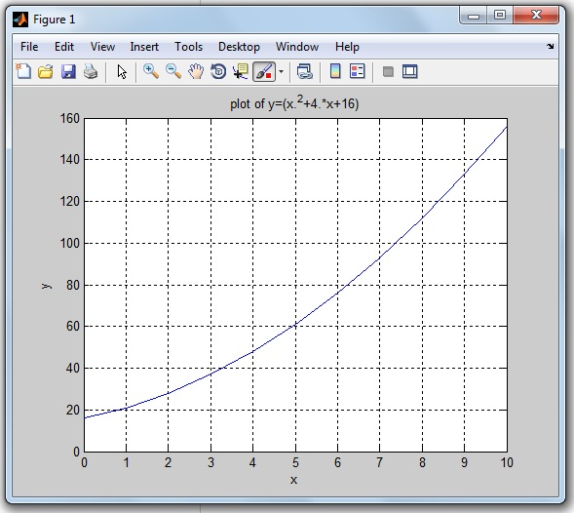

**Problem 2: How to plot a Sin Function in MATLAB?**

The function of y(x)= Sin(x)

for 0<x<10

**Solution:**

The range of the x is 0 to 10.

Here, I am considering a 0.1 difference between the range of X (0 to 10). Due to this minimum point difference, you can get a smooth sinusoidal wave.

x = (0:0.1:10) or x=(0,0.1,10)

and

y = sin(x)

The less you have a difference, the smoother you will get the graph.

**MATLAB code for Sin function:**

Write the MATLAB code for the function of y(x) as below.

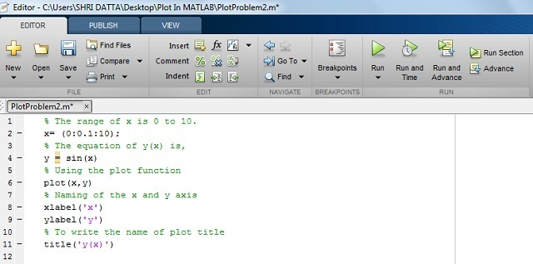

**Output in MATLAB:**

After running the program, you will get the sin wave graph.

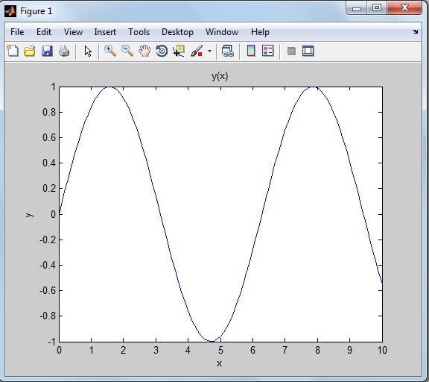

The above sinusoidal figure is drawn without the function of the grid (i.e. grid off function).

Similarly, you can plot the graph for other trigonometric functions like cos, tan, cosec, cot, sec…

**Problem 3: How to plot the Exponential Function in MATLAB?**

Let’s take an example of a trigonometric and exponential function.

The function of y(x)= (3sin(x)e^-0.4x)

for 0<x<20

**Solution:**

In this problem, this equation has trigonometric and exponential functions.

**MATLAB code for Exponential function:**

Here is code the function y(x) in MATLAB.

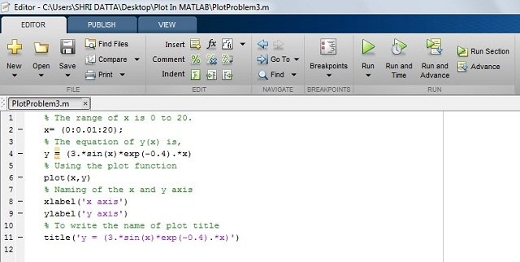

**Output in MATLAB:**

The exponential wave is getting generated after the running MATLAB program as shown in the below figure.

**Why does everyone like to Plot MATLAB Graph with different Colors?**

What if you are plotting multiple graphs on a single MATLAB display…

For plotting multiple graphs in a single window, it very difficult to distinguish one graph from another graph.

Let’s take an example.

You are plotting graphs for multiple mathematical equations like a sin wave, cos wave, exponential function on the same MATLAB display. After the running MATLAB program, you will get a number of graphs on the single MATLAB display. The end user will get more confused and will find it more difficult to understand and distinguish multiple graphs.

So you need to decorate each graph differently, like assigning a different color to each curve.

Each color describes one graph and that makes the graph self-descriptive.

**How can you decorate your MATLAB graph?**

In this tutorial, you will learn to plot the colorful graphs in MATLAB.

I am also explaining by plotting a graph for the mathematical equation on MATLAB R2013a by using a single color, simple marker and line specification.

We will also see what are the most important and useful color coding functions, marker style and line-specification designing functions available in MATLAB.

By using these functions, you can draw the graph or waveform as per your color and plotting style choice. And you can easily understand the particular equation’s graph.

Let’s begin by considering the top three essential components to decorate your graph more meaningful.

* Color
* Marker Style
* Line Specification

Explanation of these three component functions are one-by-one,

**MATLAB Plot Colors to draw the Graph**

If you are drawing any picture on paper, you have different color pencils to use.

Likewise, for plotting the graph on MATLAB, we have different colors code or functions.

Widely, eight colors are used for MATLAB graph. And each color has the corresponding color code.

The below table shows color specification with the color code.

|  |  |  |  |  |
| --- | --- | --- | --- | --- |
| **Sr.No.** | **Colour Name** | **Colour Short Name** | **RGB Triplet** | **Hexadecimal Colour Code** [Useful in MATLAB Program] |
| 1 | Black | k | [0 0 0] | ‘#000000’ |
| 2 | Blue | b | [0 0 1] | ‘#0000FF’ |
| 3 | Green | g | [0 1 0] | ‘#00FF00’ |
| 4 | Cyan | c | [0 1 1] | ‘#00FFFF’ |
| 5 | Red | r | [1 0 0] | ‘#FF0000’ |
| 6 | Magenta | m | [1 0 1] | ‘#FF00FF’ |
| 7 | Yellow | y | [1 1 0] | ‘#FFFF00’ |
| 8 | White | w | [1 1 1] | ‘#FFFFFF’ |

You can use these eight colors code to draw the colorful waveforms in MATLAB.

**MATLAB Plot Marker | Different Style to Draw the Graph**

Rather than just a simple line, do you want to make your waveform look different?

There are different marker style functions. For example, star format function, point format function, square format function, plus format function and so on.

In the below table, I am sharing the 12 marker style functions and its useful code for MATLAB graph.

|  |  |  |
| --- | --- | --- |
| **Sr.No.** | **Marker Style Name** | **Marker Style Code**  [Useful in MATLAB Program] |
| 1 | Star | * |
| 2 | Plus | + |
| 3 | Point | . |
| 4 | Circle | O |
| 5 | Square | S |
| 6 | Diamond | D |
| 7 | Pentagram | P |
| 8 | Hexagram | H |
| 9 | Triangle (Right Position) | > |
| 10 | Triangle (Left Position) | < |
| 11 | Triangle (Up Position) | ^ |
| 12 | Triangle (Down Position) | V |

How does the graph look different after using these marker styles? This we will see later in this tutorial example.

**MATLAB Plot Line Specification | Code for MATLAB Graph**

The four different spaceline codes are used for the plotting waveform or graph.

Check this blow table, for line specification code.

|  |  |  |
| --- | --- | --- |
| **Sr. No** | **Line Name** | **Line Specification Code**  [Useful in MATLAB Program] |
| 1 | Solid | – |
| 2 | Dotted | : |
| 3 | Dashed | — |
| 4 | Dash-Dot | -. |

**The syntax for plotting graph to add color, marker, and line specification:**

plot (x, y, 'colour marker linespec')

These codes are placed inside single inverted comma.

Now its time to implement all three essentials components (color, marker, and line specifier) for decorating the MATLAB graph.

**How to Plot MATLAB Graph with different colors, markers, and line specifier?**

**How to change Colour, Marker, and Line-Specification in MATLAB plot?**

Let’s take these two mathematical equations to plot the MATLAB graph.

1) y(x)=sin(2x)

2) derivative of the same function d/dx(sin(2x)) on the same graph.

**Solution:**

The first mathematical equation is trigonometric.

y1 = sin (2x)

And it’s derivative of a mathematical equation of y(x) is

y2= d/dx (y1)= 2 cos (2x)

**MATLAB code:**

Here is MATLAB code you can write to plot the graph for the function of f(x) and its d/dx (f(x)).

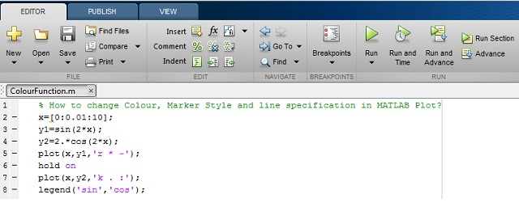

**MATLAB PLot Colors code you can copy paste:**

x=[0:0.01:10];

y1 = sin(2*x);

y2=2.*cos(2.x);

plot(x,y1,'r * -');

hold on

plot(x,y2,'k . :');

legend('sin', 'cos');

In this program, I have used the ‘legend’ function to label data series plotted on a graph. You can see in the below MATLAB output.

We are using different colors, markers and line specifications for plotting two different graphs.

**MATLAB Output:**

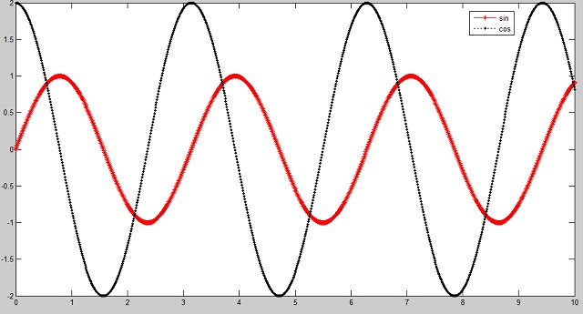

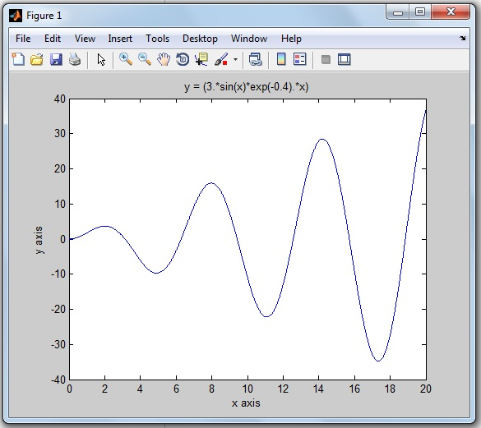

The above exponential figure is drawn without the function of the grid (i.e. grid off function).

**Problem 4: How to plot the Trigonometric Function in MATLAB?**

Let’s take an example of any trigonometric function.

y(x) = (10 cos(x) sin(x))

For the range of x is 1 to 100

**MATLAB code for Trigonometric function:**

Write the MATLAB program for the equation of y(x) as below.

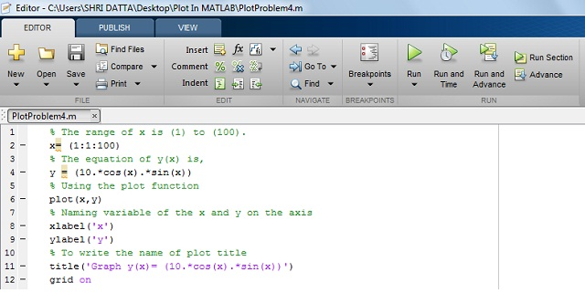

**Output in MATLAB:**

By running the code, you get the MATLAB graph for corresponding mathematical trgnomtric function.

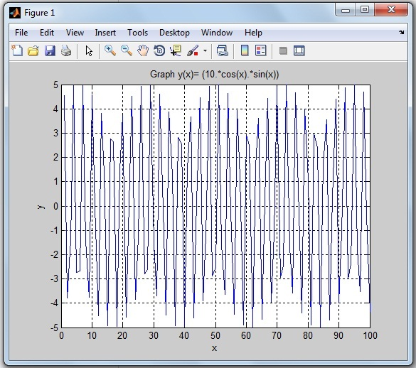

**Classifications of Two Dimensional Plots in MATLAB**

**(MATLAB 2D plot)**

MATLAB  supports more types of two-dimensional (2D) plots. We are trying to cover plots which are widely used in industry and in different projects.

Here is a list of 10 various MATLAB 2D plots.

1. Area Plot
2. Bar Plot
3. Stem Plot
4. Stairs Plot
5. Barh Plot
6. Pie Plot
7. Polar Plot
8. Compass Plot
9. Scatter Plot
10. Errorbar Plot

Now, I am describing each 2D plots by using the MATLAB code and its decorating functions in details.

**1. Area Plot**

In the Area plotting graph, you can use basic functions. It is a very easy draw.

In the MATLAB plotting, there is a function area() to plot Area.

**How to draw Area plot in MATLAB?**

**Syntax:**

The syntax for the Area plot…

area(x)

**MATLAB Code:**

As an example, we are plotting Area graph for trigonometric function. It is one of the [types of functions in MATLAB](https://dipslab.com/mathematical-functions-expressions-matlab-explain-examples/).

% To create the area plot for the given equation Sin(t)Cos(2t).

% Enter the value of range of variable 't'.

t=[0:0.2:20];

% Put the given equation

a=[sin(t).*cos(2.*t)];

area(a)

title('Area Plot')

**Note:**

* ‘%’ is used to add the comment. The line starts with ‘%’ will get executed.
* ‘;’ semicolon is used to suppress the entered value.

**Output in MATLAB:**

After the running code, you will get the Area plot as shown below.

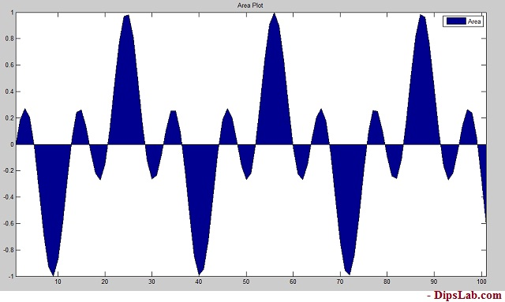

**2. Stem Plot**

In Stem plot, the discrete sequence data and variables are used. This plot is created by using the stem() function.

**How to create the Stem plot in MATLAB?**

**Syntax:**

The syntax for the stem plot is,

stem(x)

stem(x, y)

stem(----,'colour')

stem(----,'width')

stem(----,'style')

**MATLAB Code:**

Here we are creating the stem plot using the MATLAB functions for array of some random discrete numbers.

% Consisder the variable range of 'x' and 'y',

x=[3 1 6 7 10 9 11 13 15 17];

y=[14 7 23 11 8 16 9 3 23 17];

stem(x,y,'r')

title('Stem Plot')

xlabel('X axis')

ylabel('Y axis')

In this program, I used the color function (red ‘r’) and stem plot function (stem).

To decorate your graph, you can learn more about [color markers and line specifiers in MATLAB](https://dipslab.com/plot-matlab-graph-colors-markers-line-specification/).

**Output in MATLAB:**

You can see the 2-dimensional stem plot in MATLAB.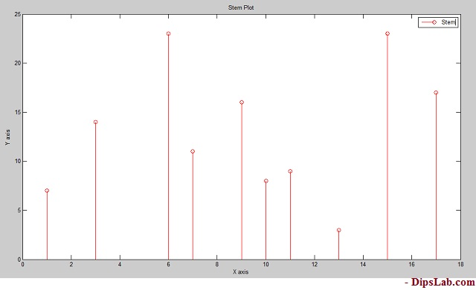

**3. Bar Plot**

You can create different types of bar plot in MATLAB. Here, I am explaining the simple bar plot code with the help of multiple functions.

**How to draw Bar plot in MATLAB?**

**Syntax:**

The syntax for the bar plot is,

bar(x,y)

bar(x,y,'colourmarkerlinespec')

**MATLAB Code:**

Let’s write a MATLAB code to plot the Bar for arrays of some random numbers.

x=[1 3 5 7 10 13 15];

y=[0 0.5 1 1.5 3 2 2];

bar(x,y)

title('Bar Plot')

xlabel('X axis')

ylabel('y axis')

**Output in MATLAB:**

Below is diagram as bar 2-dimensional plot.

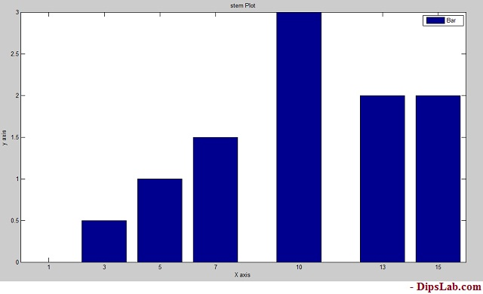

**4. Barh Plot**

Barh plot is short abbreviations of Horizontal bar. Here I am using the Barh function for the horizontal plane.

**How to draw a Barh Plot in MATLAB?**

**Syntax:**

The same syntax uses like bar plot,

barh(x,y)

barh(x,y,'colourmarkerlinespec')

**MATLAB Code:**

x=[1 3 5 7 10 13 15];

y=[0 0.5 1 1.5 3 2 2];

barh(x,y)

title('Barh Plot')

xlabel('X axis')

ylabel('y axis')

**Output in MATLAB:**

Barh plot is showing in the below diagram.

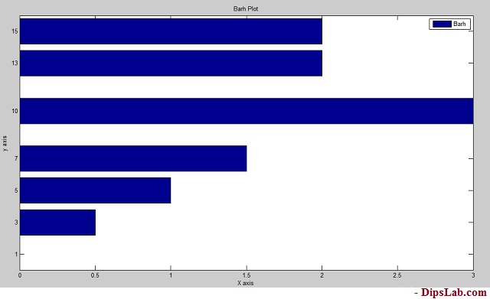

If you look at the above graph, you can see it the exact 90-degree tilt of Bar graph.

**5. Errorbar Plot**

Errorbar plot is again of the types of bar plot.

**How to draw an Errorbar Plot in MATLAB?**

**Syntax:**

The syntax for the Errorbar plot are,

errorbar(x,y)

errorbar(x,y,'colour')

errorbar(x,y','marker')

errorbar(x,y,'linespec')

**MATLAB Code:**

x=[5 10 15 20 25 30 35 40];

y=[0.1 3 4 3.5 5 6.6 7 8];

errorbar(x,y,'m')

title('Errorbar Plot')

xlabel('X axis')

ylabel('Y axis')

We are adding color function to decorate our plot.

**Output in MATLAB:**

See the 2-dimensional error plot.

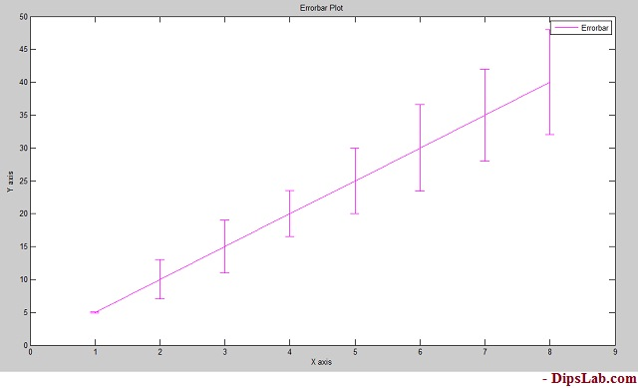

**6. Stairs Plot**

This is again one of the MATLAB 2D plots that look more like stairs.

**How to design the stairs plot in MATLAB?**

**Syntax:**

stairs(x,y)

stairs(x,y,'colourmarkerlinspec')

**MATLAB Code:**

Here, I am writing the MATLAB code of stairs plot with the black (k) color function.

x=[0 1 2 4 5 7 8];

y=[1 3 4 6 8 12 13];

stairs(x,y,'k')

title('Stairs Plot')

xlabel('X axis')

ylabel('Y axis')

**Output in MATLAB:**

Stairs plot is shown in the below diagram. You can design as per your MATLAB code.

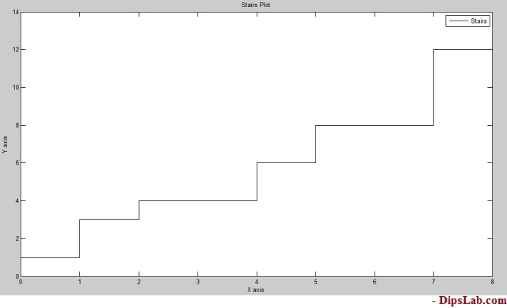

It more looks like stairs. Isn’t it?

**7. Pie Plot**

In mathematics, the pie chart is used to indicate data in percentage (%) form.

In MATLAB, you can draw different kinds of pie plots by using simple code.

**How to draw a Pie Plot in MATLAB?**

**Syntax:**

pie(x)

**MATLAB Code:**

To write the simple code for the pie plot.

x=[10 20 25 40 75 80 90];

pie(x)

title('Pie Plot')

We have 7 numbers in the array ‘x’.

When you execute the above code in MATLAB, All the values in array gets converted in the percentage.

**Output in MATLAB:**

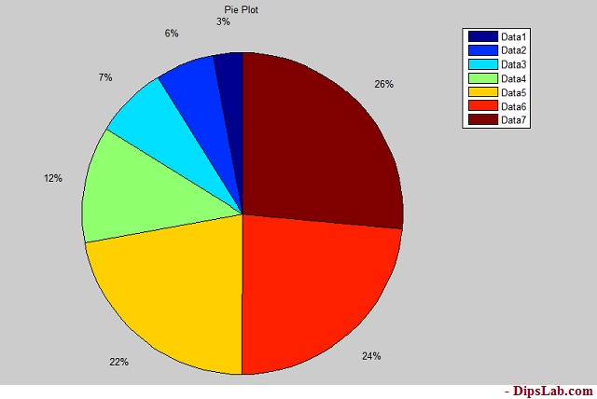

If you look at the code, we have not added any color function. By default, Pie plot is colorful. So it makes plotting Pie graph even easier.

**8. Polar Plot**

Plotting Polar plot is a little tricky.

When you are plotting the polar plot, theta and radius must be the same size.

**How to plot the Polar in MATLAB?**

**Syntax:**

In Polar plot, you can write the following syntax,

polar(theta,radius)

polar(theta,radius,'colourmarkerlinspec')

Polar plot function has arguments as theta, radius, line specification.

**MATLAB Code:**

theta=[-pi/2 pi 2*pi];

radious=[2 6 9];

polar(theta,radius,'r--')

title('Polar Plot')

Where ‘r’ considered as the red color.

**Output in MATLAB:**

The line specification and color are shown in the below diagram.  Red dashed depicts the given radius of the circle [2 6 9].

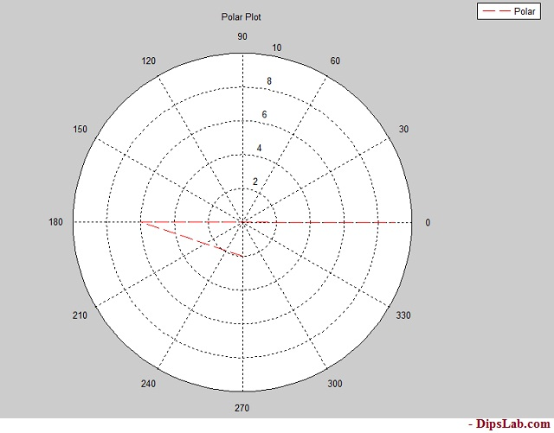

**9. Compass Plot**

Compass plot is the same as the polar plot. Both need equal quantities of theta and radius.

**How to draw a Compass Plot in MATLAB?**

**Syntax:**

The syntax of the compass plot is,

compass(theta,radius)

compass(theta,radius,'colourmarkerlinespec')

**MATLAB Code:**

For the designing compass plot, you just need to write only ‘compass’ function.

theta=[-pi pi/2 pi];

r=[2 6 9];

compass(theta,r,'b--')

title('Compass Plot')

**Output in MATLAB:**

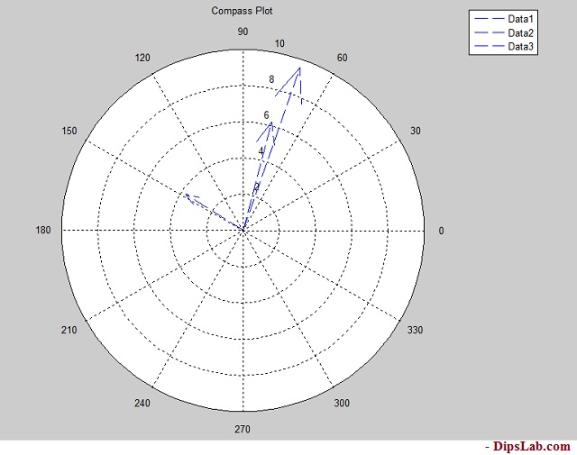

**10. Scatter Plot**

Plotting the scatter plot in MATLAB is simple.

**How to draw a Scatter Plot in MATLAB?**

**Syntax:**

For the scatter plot,

scatter(x,y)

scatter(x,y,'colourmarkerlinespec')

**MATLAB Code:**

x=[1 2 3 5 7 9 11 13 15];

y=[1.2 3 4 2.5 3 5.5 4 6 7];

scatter(x,y,'g')

title('Scatter Plot')

xlabel('X axis')

ylabel('Y axis')

**Output in MATLAB:**

After the running MATLAB code, you will see this…

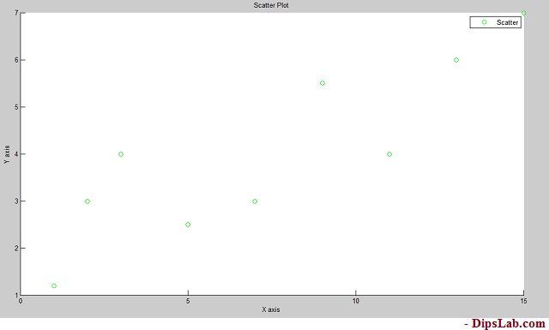

There are so many 2D plots you can draw in MATLAB. I described briefly the most useful top 10 plots.

In this tutorial, I have covered different types of plots by using examples and different functions [color |marker style| line spec]. you can read the [MATLAB 3D plot with their 5 different classifications.](https://dipslab.com/matlab-3d-plot-examples/)

Did you ever wonder seeing amazing 3D graphs in MATLAB? How to draw multiple 3D plot graphs in MATLAB?

This is an in-depth tutorial for you. I will explain the different MATLAB 3D plot examples and how to draw them.

This tutorial is an extension of a previous tutorial [two-dimensional [2D] MATLAB plot](https://dipslab.com/matlab-2d-plot-examples/).

When I share the 2D plot graph tutorial, some of the readers asked me about the 3D plot. And I decided to write about it.

This tutorial provides you the plot’s functions, syntax, and code, for example for the five main different types of 3D plots. At the end of this post, you will be able to draw your own 3D plot graph in MATLAB.

It’s amazing. Right?

Let’s start.

Table of Contents

* [3D MATLAB Plot Introduction](https://dipslab.com/matlab-3d-plot-examples/#3D_MATLAB_Plot_Introduction)
* [Classifications of Three-Dimensional Plots | MATLAB 3D plot Examples](https://dipslab.com/matlab-3d-plot-examples/#_Classifications_of_Three-Dimensional_Plots_MATLAB_3D_plot_Examples)
  + [1. Mesh 3D Plot in MATLAB](https://dipslab.com/matlab-3d-plot-examples/#1_Mesh_3D_Plot_in_MATLAB)
  + [2. Surface 3D Plot in MATLAB](https://dipslab.com/matlab-3d-plot-examples/#2_Surface_3D_Plot_in_MATLAB)
  + [3. Ribbon 3D Plot in MATLAB](https://dipslab.com/matlab-3d-plot-examples/#3_Ribbon_3D_Plot_in_MATLAB)
  + [4. Contour 3D Plot in MATLAB](https://dipslab.com/matlab-3d-plot-examples/#4_Contour_3D_Plot_in_MATLAB)
  + [5. Slice 3D Plot in MATLAB](https://dipslab.com/matlab-3d-plot-examples/#5_Slice_3D_Plot_in_MATLAB)

**3D MATLAB Plot Introduction**

In general, the three-dimensional plots consist of the three vectors (x,y,z) in the same graph.

In MATLAB, the plot3() function is used to draw the 3D plot graph. You can also use a [specified line style, marker, and color](https://dipslab.com/plot-matlab-graph-colors-markers-line-specification/?fbclid=IwAR3-6jgAVXP6ZgWFI7SImI-vlKbapPV94HKHyBGIQejn5Uyhn5295WKUPa4) for drawing 3D plots.

The general syntax to display the 3D plot is,

plot3(x,y,z)

plot3(x,y,z,Name)

plot3(x,y,z,LineSpec)

Let’s start drawing different types of the 3D plot graph…

**Classifications of Three-Dimensional Plots | MATLAB 3D plot Examples**

Here, we are considering, the five main different types of three-dimensional (3D) plots. These graphs are mostly used in the industry.

The following list of  different 3D plots as,

1. Mesh Plot
2. Surface Plot
3. Ribbon PLot
4. Contour Plot
5. Slice Plot

As a part of this tutorial about MATLAB 3D plot examples, I am describing the topmost five 3D plots one-by-one.

**1. Mesh 3D Plot in MATLAB**

The mesh plotting function is used to display the mesh plot. It produces a wireframe surface where the lines connecting the defining points are colored.

**How to create the Mesh plot in MATLAB?**

For the mesh plotting in MATLAB, you need to pass the array values to the mesh function.

**Syntax:**

Mesh function transforms the domain specified by vectors (X, Y, Z) into arrays (x,y,z).

The syntax for the Mesh Plot is,

mesh(x,y,z)

[X,Y,Z] = meshgrid(x,y,z)

**MATLAB Code:**

As an example, we are plotting the mesh 3D plot for square root mathematical function.

[x,y] = meshgrid(-10:0.1:10);

t = sqrt(x.^2+y.^2);

z =(10*sin(t));

mesh(x,y,z)

**Output in MATLAB:**

See here, you get a colorful and smooth connecting surface line of three-dimensional [3D] Mesh plot.

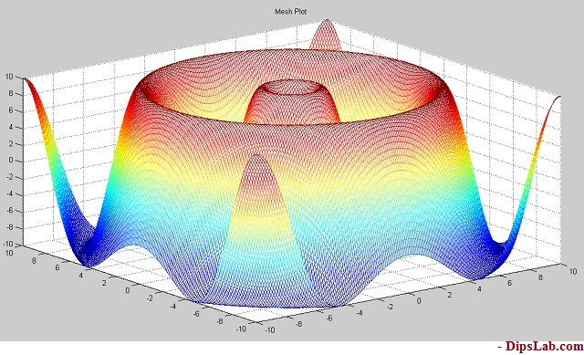

You can also plot the graph for various [Mathematical Expressions in MATLAB.](https://dipslab.com/mathematical-functions-expressions-matlab-explain-examples/)

**2. Surface 3D Plot in MATLAB**

A surface plot is somewhat similar to a mesh plot. The main difference between them is, in the surface plot, the connecting lines and the faces both will be displayed in the dark color.

**How to create the Surf plot in MATLAB?**

**Syntax:**

In the surface plot, ‘surf’ function is used. So, you can write a simple format like ‘function name(array)’.

surf(x,y,z)

surf(z)

**MATLAB Code:**

Let’s write a MATLAB code for the three-dimensional surface plot for an exponential function exp().

[x,y] = peaks(30);

z = exp(-0.9*(x.^2+0.5*(x-y).^2));

surf(x,y,z);

xlabel('\bf X axis');

ylabel('\bf Y axis');

zlabel('\bf Z axis');

title('\bf Surface Plot')

colorbar

**Output in MATLAB:**

After the getting output of surface plot, you will see the connecting lines and the faces are both displayed in the same shade.

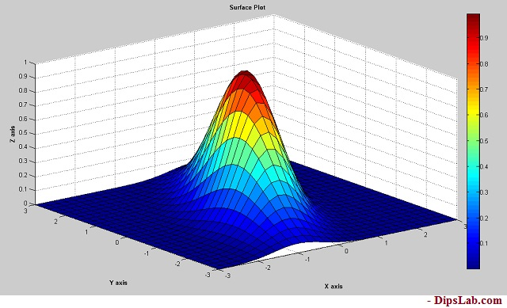

**3. Ribbon 3D Plot in MATLAB**

As the name ribbon, this 3D plot graph will be having different color ribbons.

**How to create the ribbon plot in MATLAB?**

Here, we are using ribbon() function for plotting ribbon 3D MATLAB plot.

**Syntax:**

The general syntax for writing code,

ribbon(x,y,z)

ribbon(x,y)

ribbon(z)

**MATLAB Code:**

To create a ribbon plot using peak function for mathematical function  ((x²)-(y²))

[x,y] = peaks(30);

z =[(x.^2)-(y.^2)];

ribbon(z);

title('\bf Ribbon Plot')

**Output in MATLAB:**

You can see each and every colorful shade ribbons.

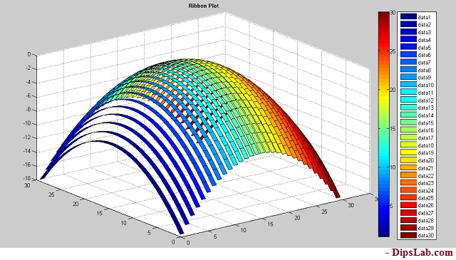

**4. Contour 3D Plot in MATLAB**

**How to create the three dimensional [3D] contour plot?**

To create the three dimensional [3D] contour plot, we are using the ‘contour3’ function.

**Note:** You can plot the Contour 2D plot by using the only ‘contour’ function.

**Syntax:**

The syntax for the three-dimensional contour plot,

contour3(x,y,z)

contour3(z)

**MATLAB Code:**

We are plotting the contour plot for the exponential mathematical equation is (exp( x²-y²)).

[x,y] = peaks(30);

z = exp(-x.^2-y.^2);

contour3(x,y,z);

title('\bf Contour Plot')

**Output in MATLAB:**

Below is a diagram for three dimensional [3D] contour plot.

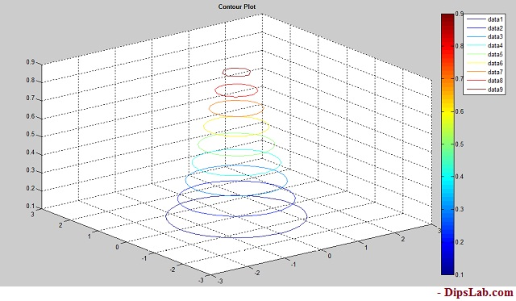

**5. Slice 3D Plot in MATLAB**

For plotting slice graph, you must know volumetric data(v), specification of three-dimensional coordinate (x,y,z), and ‘xslice, yslice, zslice’.

**Syntax:**

Slice plot’s syntax is

slice(x,y,z,v,xslice,yslice,zslice)

slice(v,xslice,yslice,zslice)

Where,

* xslice- ‘x’ coordinate data for slice plot
* yslice- ‘y’ coordinate data for slice plot
* zslice- ‘z’ coordinate data for slice plot

**MATLAB Code:**

Slice plot is little different from other 3D plots types. When you are writing MATLAB code for Slice plot, you need to specify each coordinator value.

Let’s draw the slite plot graph for an exponential mathematical equation.

[x,y,z] = meshgrid(-10:.2:10);

v = [exp((x.^2)-(y.^3)-(z.^5))];

xslice = 0.1;

yslice = 5;

zslice = 0;

slice(x,y,z,v,xslice,yslice,zslice)

colorbar

title('\bf Slice Plot')

**Output in MATLAB:**

The output looks like the below picture.

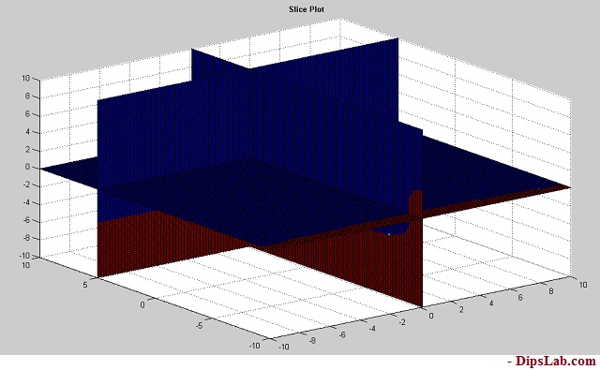

These are the topmost three dimensional  [3D] used in the industry projects.

This is all about different MATLAB 3D plot examples.